Authenticate with Firebase

Steps to implement in your xCode Project:

* Go to Firebase console https://console.firebase.google.com/ and add project.
* Write your Project name & selected your country and click on CREATE PROJECT

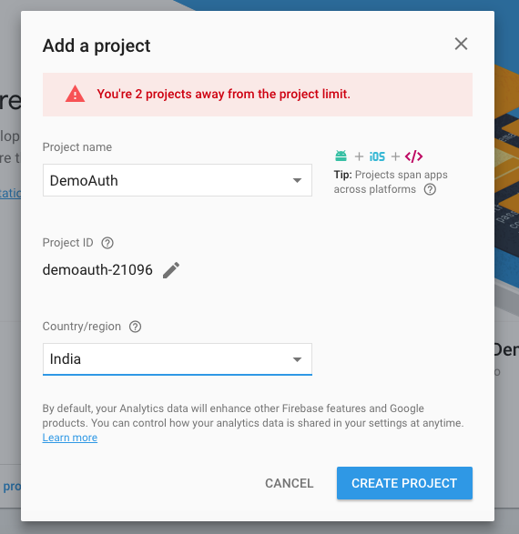

* Add Firebase to iOS App
* Provide your xCode project Bundle Id
* Provide App nick name
* Click on REGISTER APP

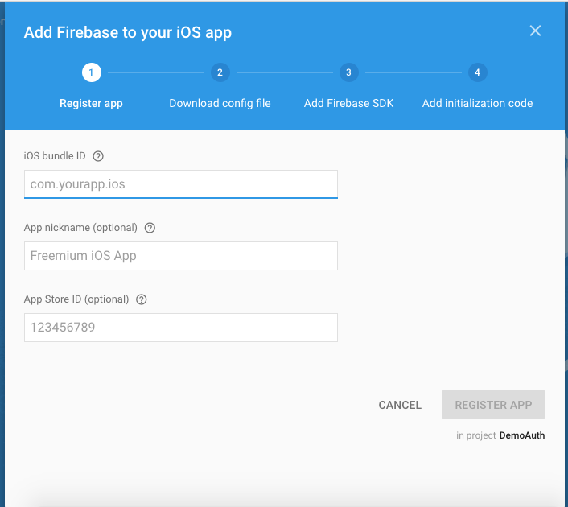

* Download Google-Service-Info.plist file and drag and drop it into your create xCode project.

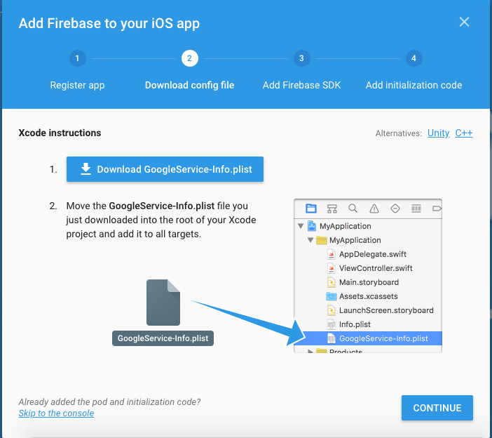

* Open the terminal and Install Pod file. Using following commands
* cd yourprojectdirectorypath and PRESS ENTER
* Write pod init and after initialization of pod file go to your project repertory and open “pod” file
* Add following pod into your pod file
* pod 'Firebase/Core'
* pod 'Firebase/Auth'
* Save the pod file
* Run the command pod install.
* Close the opened current xCode project (if any)
* Go to your project directory
* Open MyProject.xcworksapce
* Now open app delegate and write import Firebase
* Into didFinishLaunchingOption method write FIRApp.configure()
* Clean your project & build it. If you did not get any error it means you have successfully add the Firebase Authentication into your app.
* Create your signup, login or forget password UI as per your requirement.
* These are the methods you can use to signup, login and forget password to authenticate with Firebase Authentication-
* For Signup call this method:

-(void)createUserWithEmail:(NSString\*)email password:(NSString\*)password completion:(nullable FIRAuthResultCallback)completion

* For Signin call this method:

-(void)signinWithEmail:(NSString\*)email password:(NSString\*)password completion:(nullable FIRAuthResultCallback)completion

* For Reset Password call this method:

-(void)sendPasswordResetWithEmail:(NSString\*)email completion:(nullable FIRSendPasswordResetCallback)completion

* For more information please read the Google dock https://firebase.google.com/docs/reference/